- Launch one EC2 instance using Amazon Linux 2.
Launched EC2 instance using same pem.key.
ssh -iNSVArmaKeypair-NEW.pem ec2-user@52.207.143.247

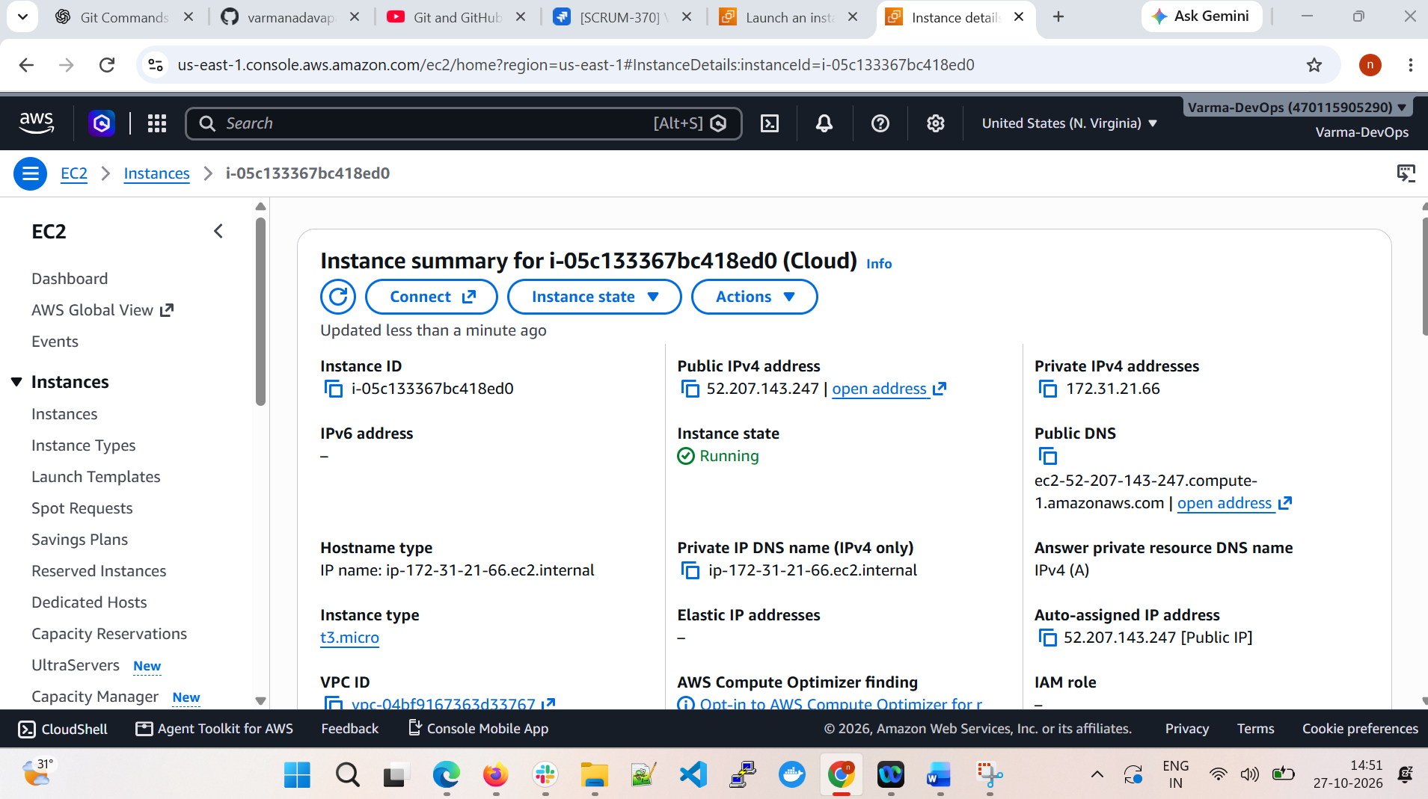
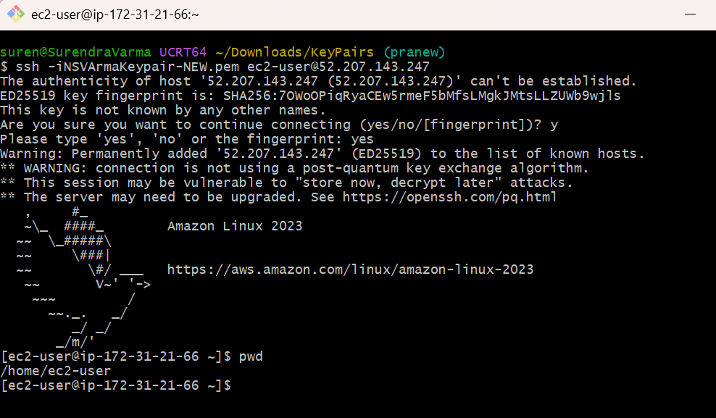

- Install Docker.

Steps:
sudo dnf update -y
sudo dnf install docker -y
sudo systemctl start docker
sudo systemctl enable docker
sudo systemctl status docker
docker --version
sudo docker run hello-world
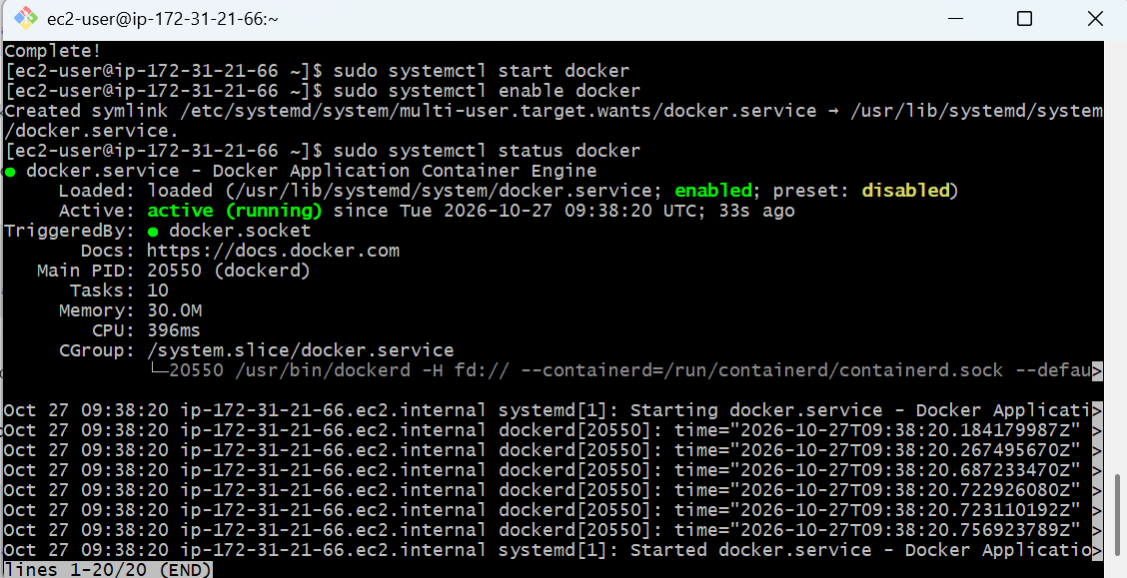

- Install Jenkins.
Install and start Jenkins
Sudo systemctl status Jenkins
Sudo systemctl start Jenkins
Sudo systemctl stop Jenkins

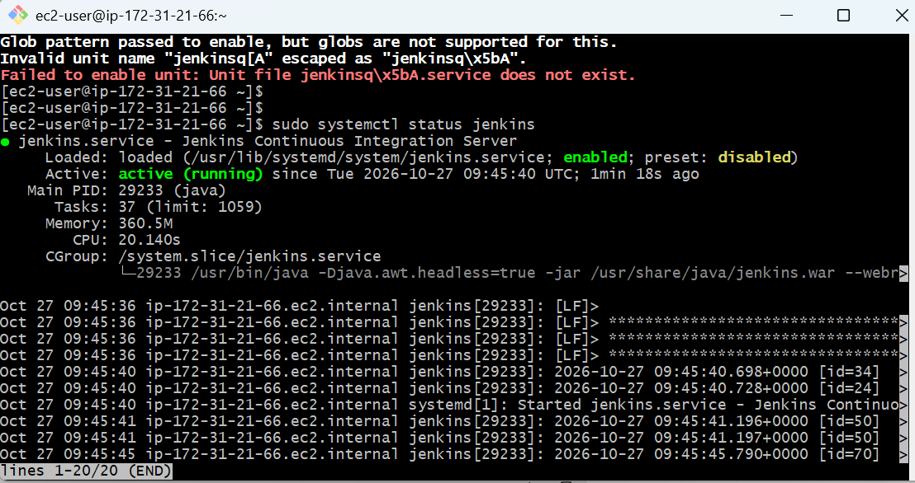

- Install Apache.
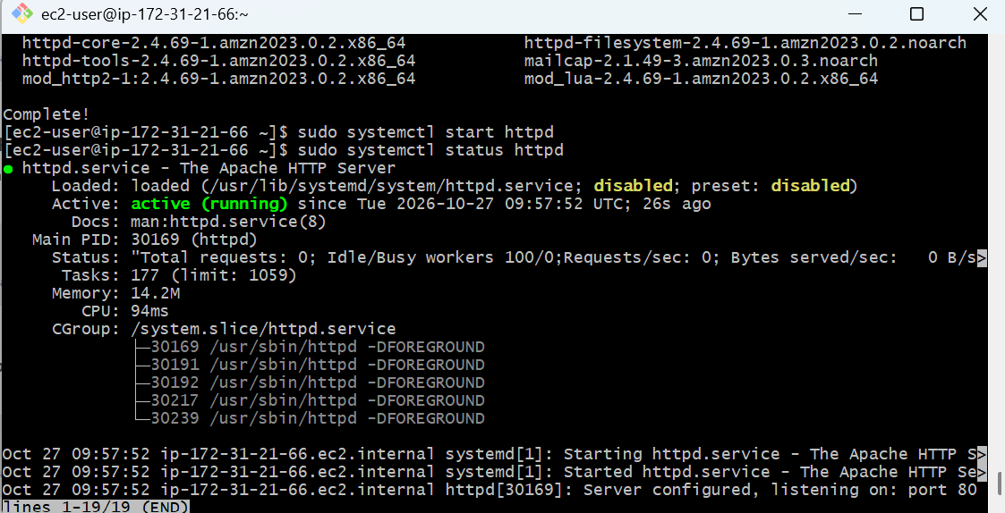

Task | Command
Install Apache | sudo dnf install httpd -y
Start Apache | sudo systemctl start httpd
Enable at boot | sudo systemctl enable httpd
Check status | sudo systemctl status httpd
Stop Apache | sudo systemctl stop httpd
Restart Apache | sudo systemctl restart httpd
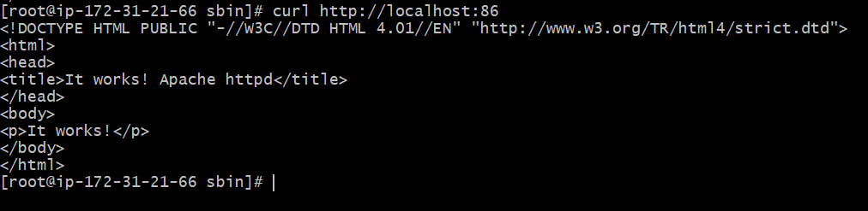

- Install Nginx.
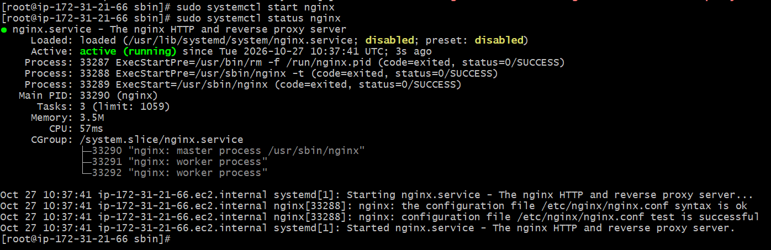
- Install Apache Tomcat.

